Erik Marrero

4/18/2020

Cs152

Hw5

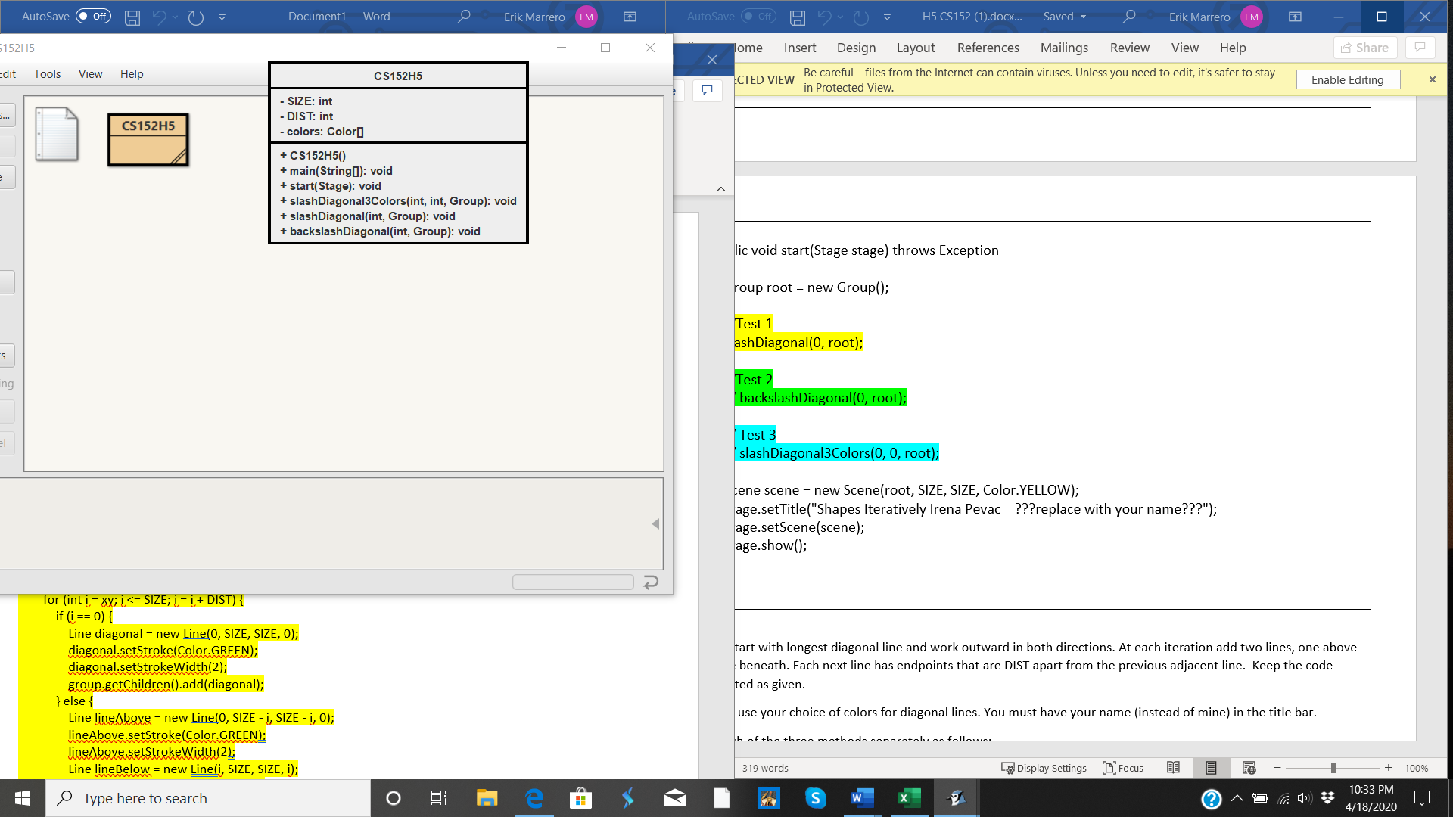



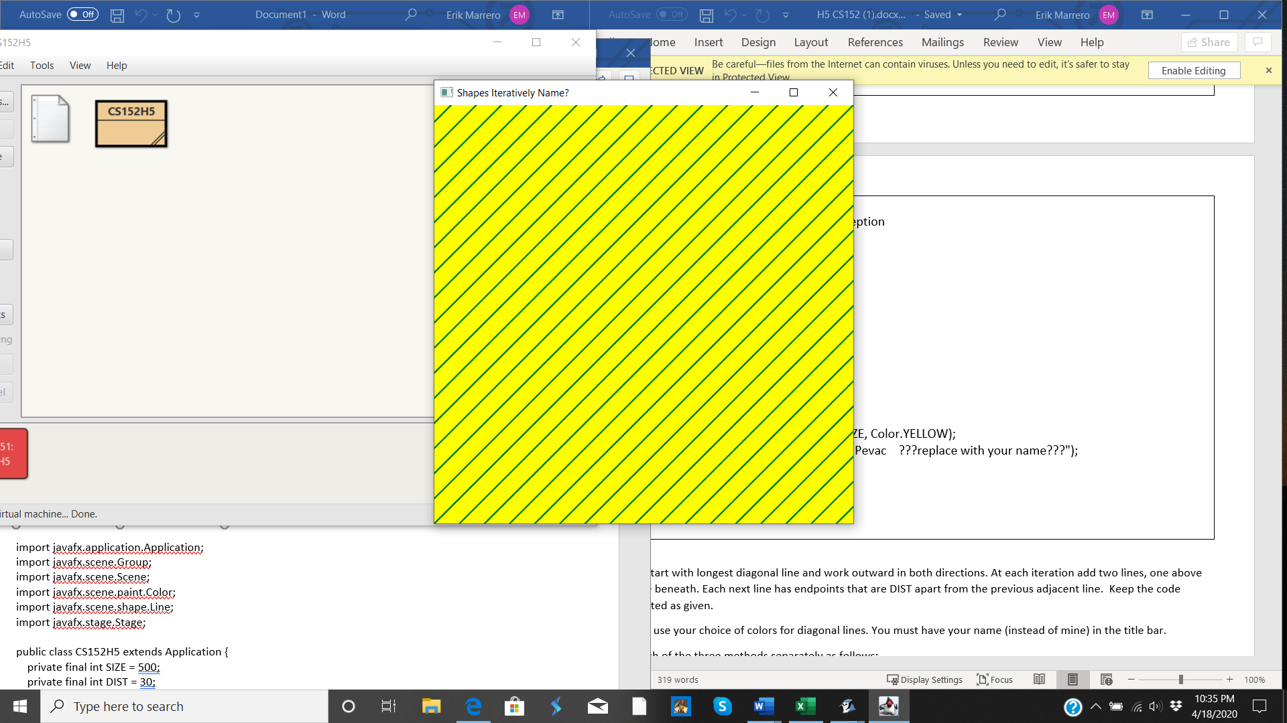

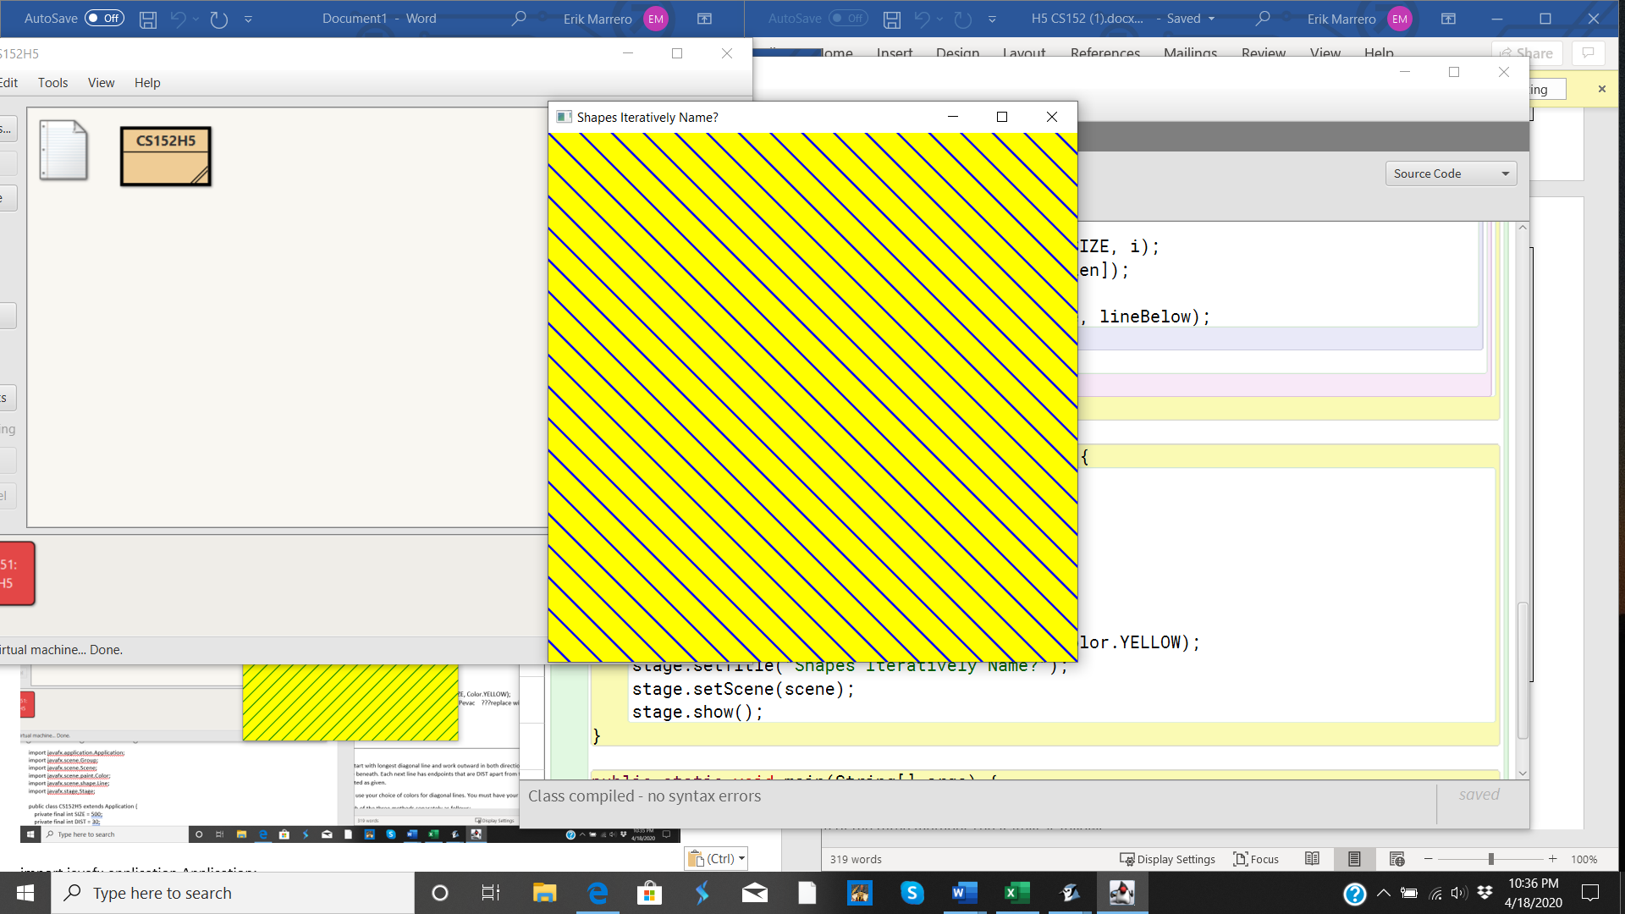

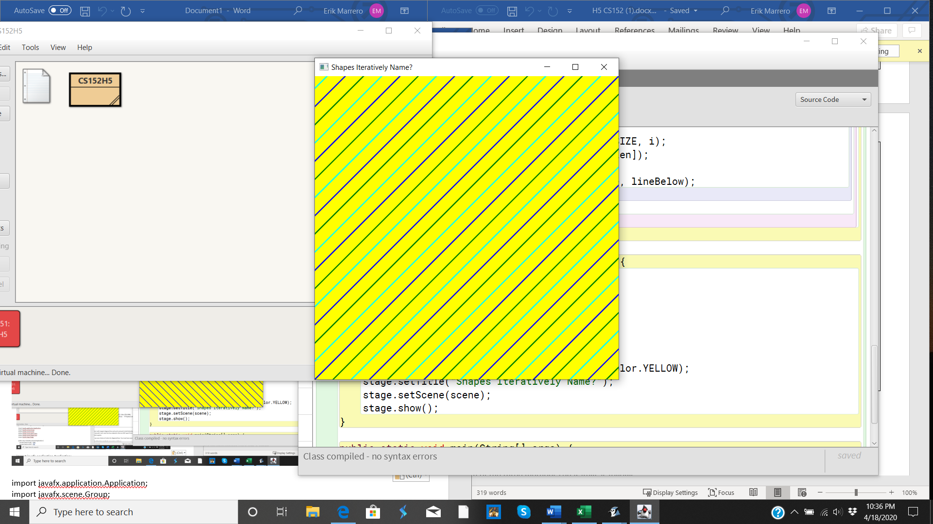

import javafx.application.Application;

import javafx.scene.Group;

import javafx.scene.Scene;

import javafx.scene.paint.Color;

import javafx.scene.shape.Line;

import javafx.stage.Stage;

public class CS152H5 extends Application {

private final int SIZE = 500;

private final int DIST = 30;

private final Color[] colors = new Color[] { Color.BLUE, Color.GREEN, Color.CYAN };

public void slashDiagonal(int xy, Group group) {

for (int i = xy; i <= SIZE; i = i + DIST) {

if (i == 0) {

Line diagonal = new Line(0, SIZE, SIZE, 0);

diagonal.setStroke(Color.GREEN);

diagonal.setStrokeWidth(2);

group.getChildren().add(diagonal);

} else {

Line lineAbove = new Line(0, SIZE - i, SIZE - i, 0);

lineAbove.setStroke(Color.GREEN);

lineAbove.setStrokeWidth(2);

Line lineBelow = new Line(i, SIZE, SIZE, i);

lineBelow.setStroke(Color.GREEN);

lineBelow.setStrokeWidth(2);

group.getChildren().addAll(lineAbove, lineBelow);

}

}

}

public void backslashDiagonal(int xy, Group group) {

for (int i = xy; i <= SIZE; i = i + DIST) {

if (i == 0) {

Line diagonal = new Line(0, 0, SIZE, SIZE);

diagonal.setStroke(Color.BLUE);

diagonal.setStrokeWidth(2);

group.getChildren().add(diagonal);

} else {

Line lineLeft = new Line(0, i, SIZE - i, SIZE);

lineLeft.setStroke(Color.BLUE);

lineLeft.setStrokeWidth(2);

Line lineRight = new Line(i, 0, SIZE, SIZE - i);

lineRight.setStroke(Color.BLUE);

lineRight.setStrokeWidth(2);

group.getChildren().addAll(lineLeft, lineRight);

}

}

}

public void slashDiagonal3Colors(int xy, int color, Group group) {

for (int i = xy; i <= SIZE; i = i + DIST) {

if (i == 0) {

Line diagonal = new Line(0, SIZE, SIZE, 0);

diagonal.setStroke(colors[color]);

diagonal.setStrokeWidth(2);

group.getChildren().add(diagonal);

} else {

int len = colors.length;

Line lineAbove = new Line(0, SIZE - i, SIZE - i, 0);

lineAbove.setStroke(colors[(len - (color % len)) % len]);

lineAbove.setStrokeWidth(2);

Line lineBelow = new Line(i, SIZE, SIZE, i);

lineBelow.setStroke(colors[color % len]);

lineBelow.setStrokeWidth(2);

group.getChildren().addAll(lineAbove, lineBelow);

}

color += 1;

}

}

public void start(Stage stage) throws Exception {

Group root = new Group();

// Test 1

slashDiagonal(0, root);

// Test 2

// backslashDiagonal(0, root);

// Test 3

// slashDiagonal3Colors(0, 0, root);

Scene scene = new Scene(root, SIZE, SIZE, Color.YELLOW);

stage.setTitle("Shapes Iteratively Name?");

stage.setScene(scene);

stage.show();

}

public static void main(String[] args) {

// Start application

launch(args);

}

}